HIMA supports safe and secure operations at INPEX-operated Ichthys LNG
(Bruehl, 9 January 2018)
As a leading independent provider of smart safety solutions, HIMA has signed a long term service contract with INPEX to support the maintenance of the safety instrumented systems at the Ichthys LNG Project in Australia. HIMA is stepping up to provide a comprehensive safety service framework. HIMA has been engaged in work on the Ichthys LNG Project since 2009 and supplied the safety instrumented system, fire and gas systems, emergency shutdown, high-integrity pressure protection system, among others.
Moving into the operational stage, HIMA is now continuing the relationship with INPEX on the Ichthys LNG Project, having secured a long term service contract. HIMA will be responsible for supporting INPEX in maintaining the safety instrumented systems on Ichthys LNG including the supply of parts, and services to ensure that the safety system is permanently operating at its optimum.
Operated by INPEX, Japan’s largest exploration and production company, the Ichthys gas field represents the most extensive discovery of hydrocarbon liquids in Australia in more than 50 years. The Ichthys LNG development includes both offshore and onshore facilities consisting of a floating production storage and offloading vessel, central processing facility and onshore LNG plant, with an accompanying 890 kilometres of subsea pipeline.
The INPEX-operated Ichthys LNG is expected to produce up to 8.9 million tons of LNG and 1.6 million tons of LPG at peak annually, with up to 100,000 barrels of condensate per day at peak.
Speaking on the contract win, Friedhelm Best, Vice President of HIMA Asia Pacific, said: “For HIMA, the signing of the long term service contract for the safety system represents a key milestone and major success for us. We are extremely pleased to be able to take this relationship with the INPEX-operated Ichthys LNG Project into the next operational stage.
“Now, we are facing a different set of challenges in ensuring that the operation is running safely round the clock without any interruption. HIMA also contributes towards secure operations in line with INPEX’s requirements.”
Touching on the collaboration with HIMA, INPEX’s Graham Ison, ‎Operations Principal Instrument and Control Engineer, said: “As we get closer to the plant start up and into the operational phase, we have signed a long term service contract with HIMA to support the maintenance of the safety instrumented systems across Ichthys LNG. This contract is important to us as we look forward to safe, reliable and efficient operations.”
Finally speaking on his experience on the close cooperation with the INPEX Operations team in Australia, Bhushan Sathe, HIMA’s National Sales Manager in Australia said “This is only the start of the journey for us to contribute towards the safe operation of Ichthys LNG over its expected life.”

Images
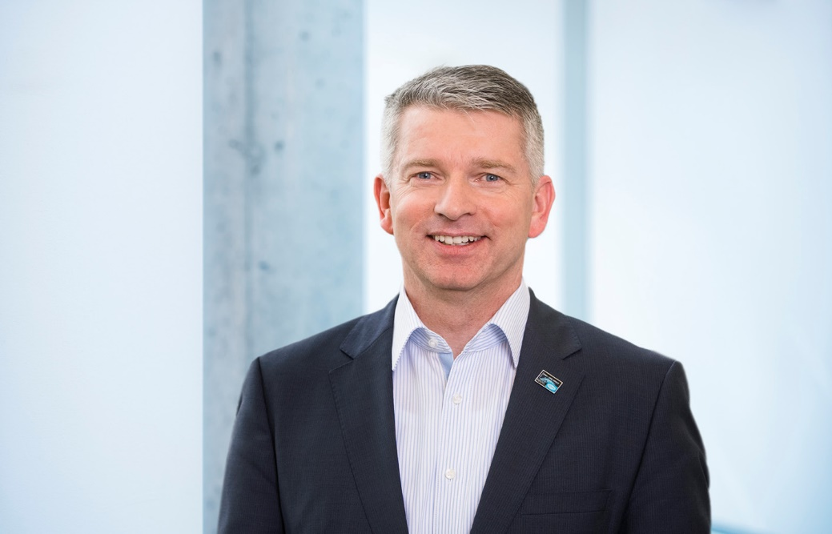
Friedhelm Best, Vice President HIMA Asia Pacific.
Image © HIMA Paul Hildebrandt GmbH
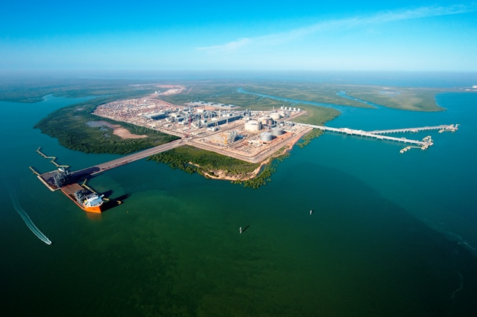
HIMA secured a long term service agreement to support the maintenance of the safety instrumented systems across Ichthys LNG.
Image © INPEX

About HIMA
The HIMA Group is the world's leading independent provider of smart safety solutions for industrial applications. With more than 35,000 installed TÜV-certified safety systems worldwide, HIMA qualifies as the technology leader in this sector. Its expert engineers develop customized solutions that help increase safety, cyber security and profitability of plants and factories in the digital age.

For over 45 years, HIMA has been a trusted partner to the world's largest oil, gas, chemical, and energy-producing companies. These rely on HIMA solutions, services and consultancy for uninterrupted plant operation and protection of assets, people and the environment. HIMA’s offering includes smart safety solutions that help increase safety and uptime by turning data into business-relevant information. HIMA also provides comprehensive solutions for the efficient control and monitoring of turbomachinery (TMC), burners and boilers (BMC) and pipelines (PMC). In the global rail industry, HIMA’s CENELEC-certified SIL4 COTS safety controllers are leading the way to increased safety, security and profitability.

Founded in 1908, the family-owned company operates from over 50 locations worldwide with its headquarters in Bruehl, Germany. With a workforce of approximately 800 employees, HIMA generated a turnover of approximately €126 million in 2016.

For more information, please visit: www.hima.com

Agency press contact / Please send voucher copies to

Ian Clay, Technical Publicity
Capital Tower, 168 Robinson Road, Singapore 068912
Mobile: +65 9017 4778
E-Mail: iclay@technical-group.com

Lee Kok Leong, Technical Publicity
Mobile: +65 9644 6072
E-Mail: kllee@technical-group.com

Press contact HIMA Headquarters

HIMA Paul Hildebrandt GmbH
Daniel Plaga
Group Manager Global PR

Albert-Bassermann-Straße 28
68782 Bruehl
Phone: +49 6202 / 709-405
Fax: +49 6202 / 709-123
E-Mail: d.plaga@hima.com

www.hima.com

