Remote Access: Securing the Safety Periphery
- HIMA presents solution for reliable remote maintenance
- Introduction of strategic roadmap that includes the use of Industrial IoT technology in safety applications
(Orlando, FL, USA, February 3, 2020)
At the 24th Annual ARC Industry Forum in Orlando, Florida, February 3 - 6, the HIMA Group will present the upcoming roadmap and new services complementing the HIMA Smart Safety Platform (SSP). HIMA introduces a solution for remote maintenance in the industrial context, living up to the standards set by SSP, the world’s first scalable safety platform with built-in cybersecurity.
As the HIMA SSP offers a future-proof solution to the process industry that is both safe and secure, the new remote maintenance solution is the perfect and logical addition: It helps to reduce operating costs and increases productivity, while the combination with SSP is protecting the plant against the growing risk of cybersecurity attacks.
“Having both safety and security in mind, many companies face a tough choice, when making a decision regarding remote maintenance”, says Dr. Alexander Horch, VP R&D and Product Management at HIMA. “On the one hand, everybody can see the potential of substantial cost advantages if remote maintenance of process systems is carried out via public networks. On the other hand, though, there are substantial security risks to be reckoned with as well. If a company hasn’t established effective protection mechanisms, it only takes one weak spot to jeopardize the entire production process. With SSP we made the ‘core’ secure and now we follow up with a complete unitary solution or remote access, which meets highest requirements regarding safety and security.”

Remote maintenance solution fulfilling highest standards for safety and security
To address the challenges all companies in the industrial context face, HIMA’s remote maintenance solution fulfils the highest standards for safety and security, without any restrictions on scalability. HIMA clients and new customers alike can easily implement a secure remote maintenance system which conforms to requirements set by the German Federal Office for Information Security (BSI). Hardware, software and support come all from one source, reducing complexity perceptibly.
Future roadmap includes data diodes
The future roadmap focuses on the secure connection of mobile workers, encrypted communication via the internet, interface control and internal network segmentation with firewalls, as well as the networking of highly critical systems and ‘data diodes‘. Data diodes are integral components of modern automation systems such as NAMUR Open Architecture (NOA) or Open Process Automation. Secure data transmission from a highly sensitive area to a less sensitive one places high demands on the components. Especially when all boundary conditions for performance, operability, economy and safety are taken into account.
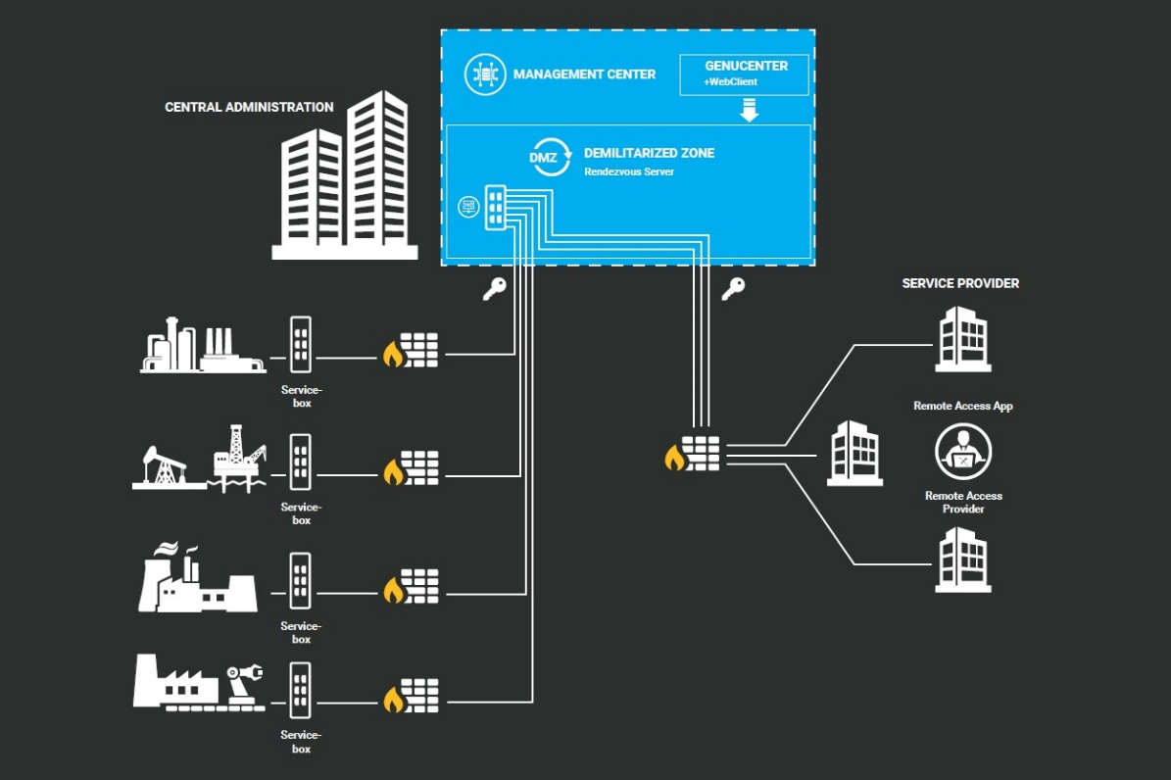
Image 1: HIMA offers a solution that meets the highest requirements for secure remote maintenance in industrial environments.
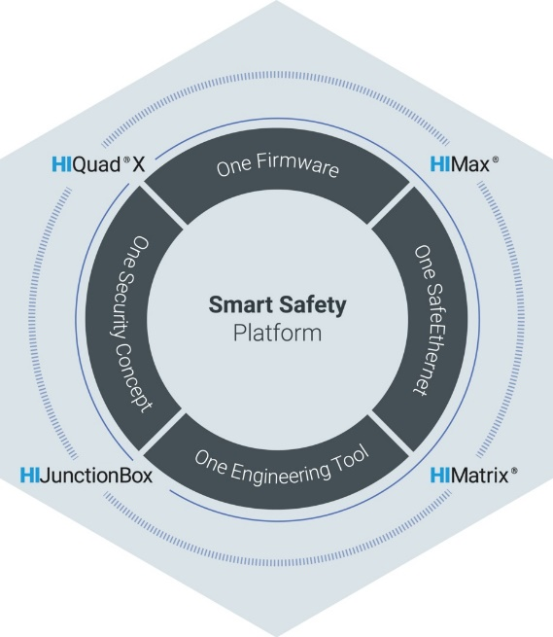
Image 2: The HIMA Smart Safety Platform provides plant operators with maximum security to ensure that safety automation and critical assets are always protected.
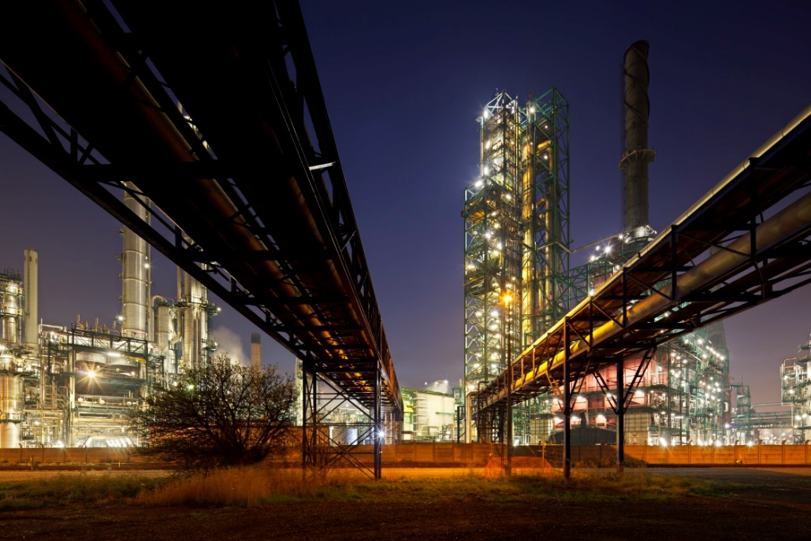
Image 3: At the ARC Forum, HIMA presented the company's strategic roadmap that includes the use of Industrial IoT technology in safety systems. Until now, these types of open and standardized concepts were often excluded from safety systems, mainly due to security concerns.
All images © HIMA Group

About HIMA
The HIMA Group is the world's leading independent provider of smart safety solutions for industrial applications. With more than 35,000 installed TÜV-certified safety systems worldwide, HIMA qualifies as the technology leader in this sector. Its expert engineers develop customized solutions that help increase safety, cyber security and profitability of plants and factories in the digital age. For over 45 years, HIMA has been a trusted partner to the world's largest oil, gas, chemical, and energy-producing companies. These rely on HIMA solutions, services and consultancy for uninterrupted plant operation and protection of assets, people and the environment. HIMA’s offering includes smart safety solutions that help increase safety and uptime by turning data into business-relevant information. HIMA also provides comprehensive solutions for the efficient control and monitoring of turbomachinery (TMC), burners and boilers (BMC) and pipelines (PMC). In the global rail industry, HIMA’s CENELEC-certified SIL4 COTS safety controllers are leading the way to increased safety, security and profitability. Founded in 1908, the family-owned company operates from over 50 locations worldwide with its headquarters in Bruehl, Germany. With a workforce of approximately 800 employees, HIMA generated a turnover of approximately €123 million in 2017. For more information, please visit: www.hima.com

Press contact HIMA Headquarters

HIMA Paul Hildebrandt GmbH
Daniel Plaga
Group Manager Global PR

Albert-Bassermann-Straße 28
68782 Bruehl
Phone: +49 6202 / 709-405
Cell : +49 172 / 3224 944
E-Mail: d.plaga@hima.com

Agency press contact / Please send voucher copies to

Mark Herten, Publitek  Post Office Box 12 55, 21232 Buchholz  Phone: +49 (0)4181 968 09820  Mobile: +49 (0)1520 748 3901  E-Mail: mark.herten@publitek.com | Carsten Otte, Publitek  Phone: +49 (0)4181 9680 09880  Mobile: +49 (0)1520 915 8629  E-Mail: carsten.otte@publitek.com

