HIMA presents solution for reliable remote maintenance compliant to the newest expert recommendations
(Brühl, 6 August 2019)
HIMA Paul Hildebrandt GmbH, world's leading independent provider of smart safety solutions for industrial applications, together with their strategic partner genua GmbH, specialist in IT security, are proud to present a solution for remote maintenance in the industrial context. This remote maintenance solution fulfils the highest standards for safety and security, without any restrictions on scalability.
“When it comes to the question of ‘Remote maintenance, yes or no?’, a lot of companies still face a tough choice,” says Heiko Schween, Head of Automation Security at HIMA. “On the one hand, they can see the potential of substantial cost advantages if remote maintenance of process systems is carried out via public networks. On the other hand, though, there are substantial security risks to be reckoned with as well. If a company hasn’t established effective protection mechanisms, it only takes one weak spot to jeopardize the entire production process.”
High demands on a secure remote maintenance solution
If safety and security are put at risk, this can result in financial loss due to interruptions in production. In the worst case scenario this can even lead to far-reaching damage to personnel and to the environment. All this means it is essential to weigh the benefits against the risks. The German Federal Office for Information Security (BSI), in its recommendations regarding cyber security (BSI-CS 108 | Version 2.0 | 07.2018) provides an overview of the general requirements for remote maintenance in industrial environments.

Secure protocols and top quality encoding
The HIMA remote maintenance solution makes use of secure protocols such as SSH, IPsec and SSL / TLS. With a symmetrical encoding process such as AES256, for example, top quality encoding comes into use as well.
In addition to the password, authentication of a user can also be established by a unique identifier word generated with a Yubikey token in combination with RSA encoding.
All from one source and fully scalable
This means that existing HIMA clients and new customers alike can easily implement a secure remote maintenance system which conforms to BSI requirements, with hardware, software, and support all from one source. Complexity is perceptibly reduced. Investment security is assured by way of optionally extendible and complete IPv6 support and ongoing product upkeep. “This means that HIMA have a complete unitary solution to offer, which meets BSI requirements regarding safety and security,” says Heiko Schween.
There are no restrictions on the secure integration of automation solutions from third-party suppliers. And that means users do not encounter any limitations due to a proprietary solution. A central management system means that HIMA remote maintenance is easily scalable for large environments, too. From the single solution, via the complete solution, and on to the incorporation of an individual critical system, all the requirements can be fulfilled, on the foundation of really high availability.
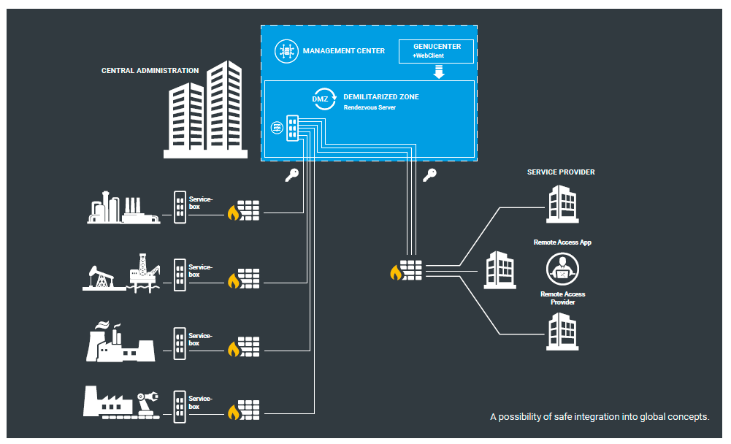
The new HIMA solution fulfils all requirements for secure remote maintenance in the industrial environment and conforms to the recommendations of the German Federal Office for Information Security.
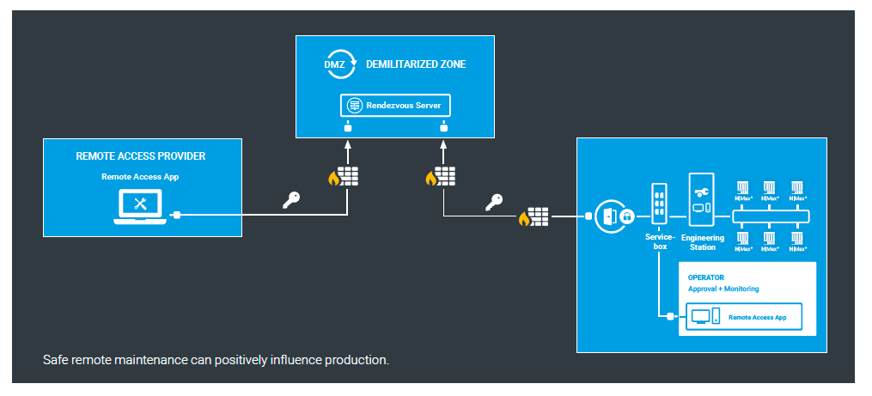
With the Rendezvous Server, a dedicated server is installed as the central remote maintenance gateway in a predetermined demilitarized zone (DMZ). This solution means that there can be no authorization for unilateral interventions by the remote maintenance service to client networks. Users thus retain full control of maintenance accesses to the networks.
Images © HIMA Paul Hildebrandt GmbH

About HIMA
The HIMA Group is the world's leading independent provider of smart safety solutions for industrial applications. With more than 35,000 installed TÜV-certified safety systems worldwide, HIMA qualifies as the technology leader in this sector. Its expert engineers develop customized solutions that help increase safety, cyber security and profitability of plants and factories in the digital age. For over 45 years, HIMA has been a trusted partner to the world's largest oil, gas, chemical, and energy-producing companies. These rely on HIMA solutions, services and consultancy for uninterrupted plant operation and protection of assets, people and the environment. HIMA’s offering includes smart safety solutions that help increase safety and uptime by turning data into business-relevant information. HIMA also provides comprehensive solutions for the efficient control and monitoring of turbomachinery (TMC), burners and boilers (BMC) and pipelines (PMC). In the global rail industry, HIMA’s CENELEC-certified SIL4 COTS safety controllers are leading the way to increased safety, security and profitability. Founded in 1908, the family-owned company operates from over 50 locations worldwide with its headquarters in Bruehl, Germany. With a workforce of approximately 800 employees, HIMA generated a turnover of approximately €123 million in 2017. For more information, please visit: www.hima.com

Press contact HIMA Headquarters

HIMA Paul Hildebrandt GmbH
Daniel Plaga
Group Manager Global PR

Albert-Bassermann-Straße 28
68782 Bruehl
Phone: +49 6202 / 709-405
Cell : +49 172 / 3224 944
E-Mail: d.plaga@hima.com

Agency press contact / Please send voucher copies to

Mark Herten, Publitek  Post Office Box 12 55, 21232 Buchholz  Phone: +49 (0)4181 968 09820  Mobile: +49 (0)1520 748 3901  E-Mail: mark.herten@publitek.com | Carsten Otte, Publitek  Phone: +49 (0)4181 9680 09880  Mobile: +49 (0)1520 915 8629  E-Mail: carsten.otte@publitek.com

